|  |
| --- |
| THE ALMABETTER |
| **APPLIANCES ENERGY PREDICTION** |
| **Gulzar** |
| **Data science trainees,**  **AlmaBetter, Bangaluru** |
|  |
| **6/27/2022** |

|  |
| --- |
| **Abstract**  Prediction of the energy consumed by household appliances is a challenging research topic owing to a transition toward the Internet of Everything. In this study, the energy consumptions of appliances were predicted using a ML model based method, wherein the linear, lasso, ridge, decision tree, random forest, gradient boosting, xgb, adaboost and lgbm regression algorithms were employed. The two objectives of the present study were the maximization of the prediction performance of the algorithms and minimization of the number of selected features. The proposed method was tested on the [appliances energy](https://www.sciencedirect.com/topics/engineering/appliance-energy) prediction dataset which was downloaded from a public dataset from Reliable Prognosis. |

**1.Problem Statement**

The energy prediction will come under supervised machine learning task aiming to Appliance energy consumption for a house based on factors like temperature, humidity & pressure. Many techniques, Gradient descent algorithm, and linear regression etc, have been applied to predict the energy consumption.

In the era of smart homes, the ability to predict energy consumption not only save money for users but also help in generating money for the user by giving excess energy back to Grid (in case of solar panels usage). In this case regression analysis will be used to predict Appliance energy usage based on data collected from various sensors.

**1.1 Data Set**

Below are the info that is available in given dataset-

lights - Energy use of light fixtures in the house

* lights - Energy use of light fixtures in the house
* T1 - Temperature in kitchen area
* RH_1 - Humidity in kitchen area.
* T2- Temperature in living room area.
* RH_2 - Humidity in living room area
* T3 - Temperature in laundry room area
* RH_3 - Humidity in laundry room area
* T4 - Temperature in office room
* RH_4 - Humidity in office room
* T5 - Temperature in bathroom
* RH_5 - Humidity in bathroom
* T6 - Temperature outside the building
* RH_6 - Humidity outside the building
* T7 - Temperature in ironing room
* RH_7 - Humidity in ironing room
* T8 - Temperature in teenager room 2
* RH_8 - Humidity in teenager room 2
* T9 - Temperature in parents room
* RH_9 - Humidity in parents room
* T_out - Temperature outside (from Chievres weather station )
* Press_mm_hg - Pressure (from Chievres weather station)
* RH_out - Humidity outside (from Chievres weather station)
* Windspeed - Wind speed (from Chievres weather station)
* Visibility - Visibility (from Chievres weather station)
* Tdewpoint - Tdewpoint (from Chievres weather station)
* rv1 - Random variable 1
* rv2 - Random variable 2
* Date - Date and time format
* Appliances - Energy used by appliances (Target Feature)

**2. Introduction**

Understanding the consumption of electricity in daily home appliances such as washing machines, televisions, microwaves etc., which constitutes the major part of electricity demand of a low energy household, could provide major insights in utilization of electricity. Studying this data is important in finding the key factors that could influence the electricity consumption in appliances and thereby work on those factors to decrease the consumption of electricity by appliances. The problem predicts the appliances usage of electricity based on various factors that could influence the consumption of electricity.

The electricity consumption in low energy houses is determined by two main factors, the number of electrical appliances in the house and the usage of appliances by the occupants of the house. There are many factors that could influence the usage by appliances, some of the factors that could influence are the indoor environmental factors near the vicinity of the appliances such as temperature, humidity, light, vibrations etc. The occupancy level of house in different locations could also help in determining the usage of appliances. Developing prediction models for this problem can be useful for many applications such as detecting abnormal energy usage patterns, determining energy demand, to use in building performance simulation etc.

The goal of the project is to predict the energy of the appliances using various features. Regression model is used in this problem for prediction of energy use of appliances . The problem is non-trivial as it has non-linear behaviour, that is, it is difficult to predict the energy based on the given features as it is on dependent on all of them. Also, the data had time-series feature which needed some specific pre-processing but as for now time-series did not taught in class yet so as of now , I am not proceeding it with time-series approach instead of that I will be solving our problem using ML techniques. But if given more time, I would give a chance to time series also and would check how our data behaves on time-series models. Even if I am not proceeding with time series approach, we can extract useful information from the date-time feature.

**3. EDA**

* **Observing and Exploring Dataset**

After loading the dataset we performed some basic functions and methods for knowing the data type. This process helped us figuring out various aspects and relationships among the appliances energy consumption and the data factors. It gave us a better idea of which factor behaves in which manner compared to the appliances energy consumption.

After observing the data we would say that there are 29 columns and 19735 rows. According to appliances column there are range of energy consumption which is vary between 10 to 1080 Wh. May be there can be some outliers also we will also handle that.

* **Null, Missing and Duplicate Values Treatment**

It is an important aspect of Data Cleaning because there can be some null, missing and duplicate values in our dataset. But our dataset doesn't contains a null or missing values which might tend to disturb our accuracy, if it has null or missing values then we have to drop them at the beginning of our project in order to get a better results.

* **Dropping unnecessary Column**

Our dataset does contains some unnecessary column like Lights, we didn't need it for analysis so we can drop them out from dataset(as per our problem statements).

* **Outliers handling**

We have a lot of outliers in our dataset and in our target column. According to IGR method we have 2138 rows with outliers. We have done both method removal and non-removal of outliers but removal of outliers done great with our accuracy.

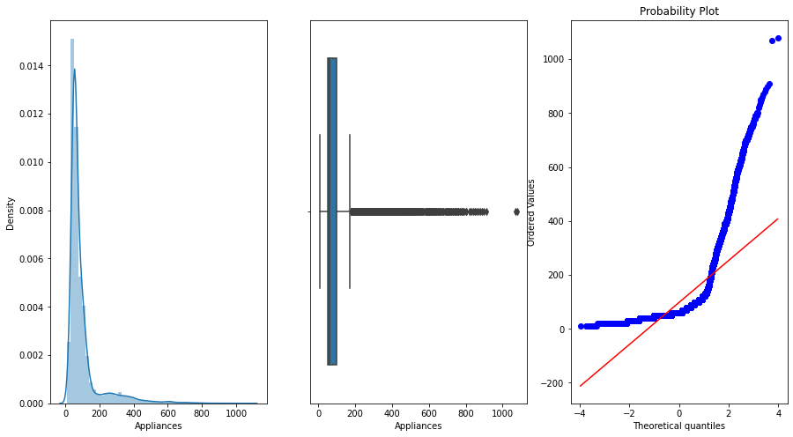

* **Analyzing and Visualization of data(Including Distribution)**

In these steps we used plots like box plot to check the outliers and we used histogram for observing the distribution of our features as well as probability plot. We also used heatmap for finding correlation between our target and other features.

Next we used bar plot for finding top hours and weekday in which energy consumption is higher than other hours and weekdays respectively after extracting some information from date column. We are using rel plot and kde plot also for our target feature.

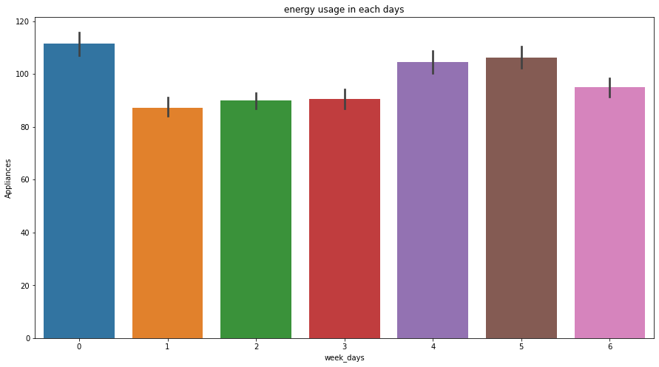

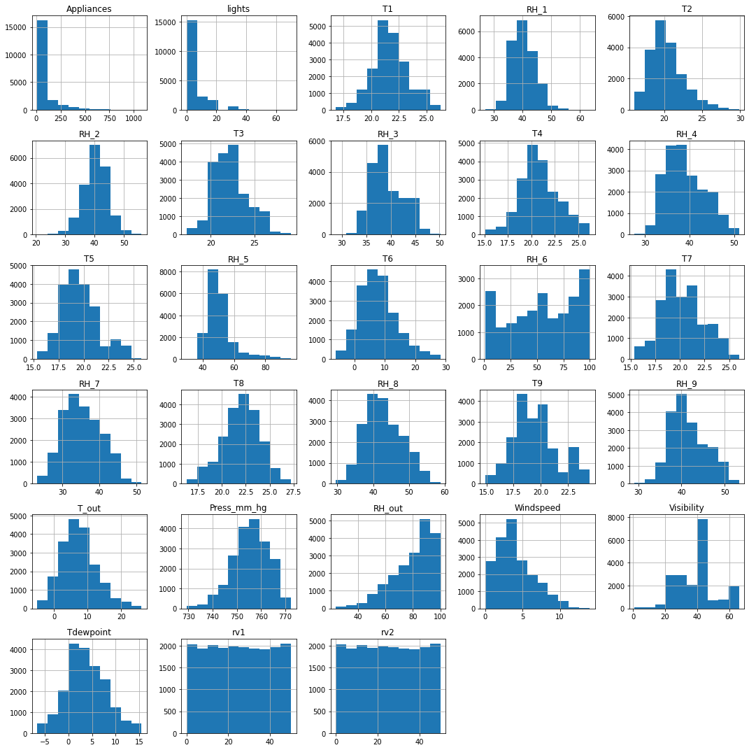

After observation we can say that most of our feature are normally distributed except appliances, RH_5, RH_out, T6, T5,T_out, rv1 and rv2 . We also tried Transformation like log,sqrt etc. but didn't get the good accuracy so we removed or commented those transformation.

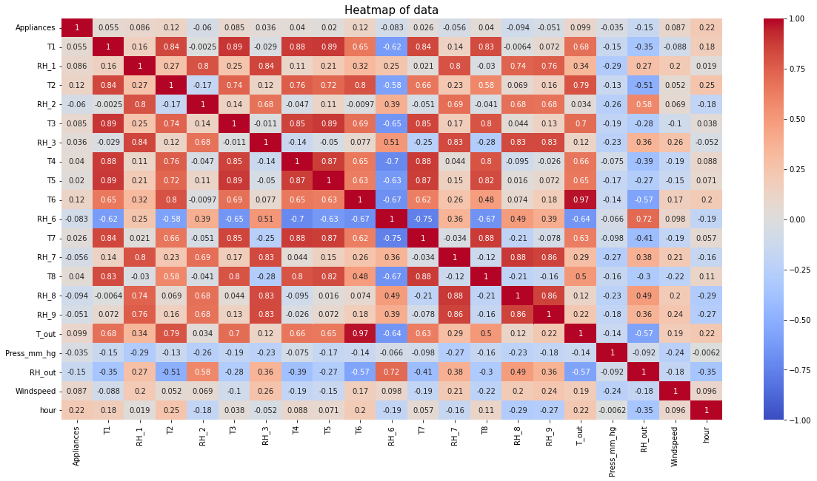

* **Using different visualization methods**

For visualization we tried various plots like:

* **Prob Plot**
* **Bar Plot**
* **Rel Plot**
* **Histogram**
* **Box plot**
* **Kde Plot**
* **Heat map**

**4. Feature Engineering**

For feature selection we used two method -

1. **VIF Method-** In this method we didn't get good score so we skip(commented) it.
2. **Correlation Method-** This method gives us promising results so we move ahead with correlation method and removed some unnecessory features like rv1,rv2,T6 and T9 etc.

**5. Preparation for Model Making**

* **Splitting** - In this particular steps we splitted our data to train and test data with 20% test data.
* **Scaling** - We used two scaler Min-max and Standard for our data but Standard scaler gives good results so we proceed further with it.
* **PCA** - we also applied pca on our data and play with but none of n_components gives good accuracy so we removed or commented it as well.
* **F-regression and SelectKbest** - We also tried these for all and top features but none of them done great with our results.

**6. Making Models**

I used lot of regression processes to train my model in the beginning such as :

* Linear Regression
* Ridge Regression
* Lasso Regression
* Decision Tree Regressor
* Lgbm Regression
* Random Forest Regressor
* Gradient Boosting Regressor
* Adaboost Regressor
* XGB Regressor

Top 2 models were selected from these above using pre-train set on the basis of good r2 score and rmse. And they were used for hyperparameter tuning for further improvement.

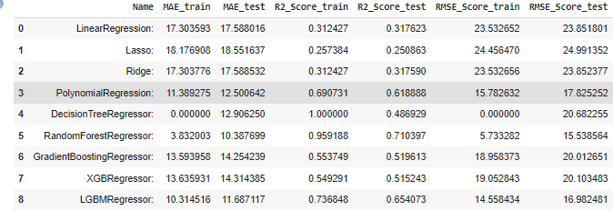

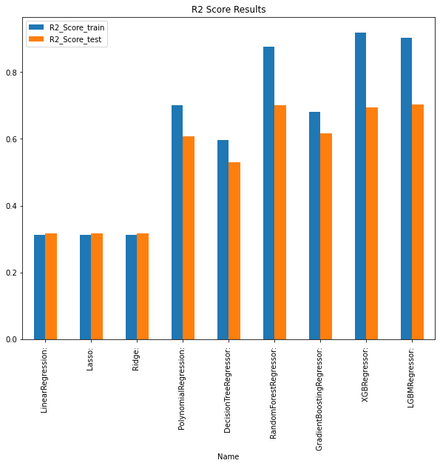

Note- The lower the value of the RMSE and the higher the R2 the better the model.

**7. Hyperparameter Tuning**

We only did tuning for top 2 models :

* **Random Forest Regressor**: Random forest for regression operates by constructing a multitude decision trees at training time. It uses number of estimators that fit a number of decision trees on various sub-samples of dataset. It uses averaging to improve the predicted results and controls over-fitting. The main advantage of random forest regression is that prevents over-fitting. Random Forest is good at handling numerical data and it is also able to capture the non-linear interaction between the features and the target.

I used an inbuilt sklearn.ensemble.RandomForestRegressor() with the help of Grid search(commented) and bayesian search with n_estimators, max_depth, min_samples_leaf, min_samples_split and max_features as my hyperparamter to tune the model.

After playing alot with these parameters we got our best parameter which were improving our r2 score

* **Lgbm Regressor**: We also gone for Lgbm Regressor for tuning with the help of Grid search(commented) and bayesian search with n_estimators, max_depth, min_samples_leaf and min_samples_split as my hyperparamter to tune the model.

After playing alot with these parameters also we we didn't got our best parameter which can improving our r2 score as well as rmse

**8. Final Result**

For test set, the best model obtained after validation was used and the best parameter as well. The model performance was now tested on the test set and according to results Random Forest is doing good from all of the above model so our final model for this dataset is Random Forest Regressor. It was observed that the random forest gives best results as it prevents overfitting and optimizes the data. It is also seen that the error is not that low and this might be due to the dataset available. The main reason for this is that appliances’ consumption profile is highly variable. The features which were present were not all dependent on the target as observed from the correlation results and that resulted into high error. Whereas, elimination of these features could have helped a little but they play different roles for different regressors and that’s why it was little difficult to determine which one to consider and which one to eliminate for a regressor. Therefore, I just found which features were more important for the model performance and arranged them in an order where top one is the best feature and last one is the least important feature. The result found is as follows:

1. T2

2. RH_8

3. RH_1

4.T8

5. RH_5

6. RH_6

7. T_out

8.RH_out

11. Tdewpoint

12. T4

13. T7

14. T5

15. T3

16. Windspeed

17. T1

**9. Conclusion**

That's it! We have reached the end of our project.

Starting with loading the data so far we have done EDA , null values treatment, dropping unnecessary columns, outliers handling, visualization, knowing the distribution, feature engineering, model making and then finalizing our best model with the help of hyperparameter tuning.

The Random Forest Regressor was the best model when compared with rest all models for this data set. For all the models This regressor worked the best because it prevents the data from overfitting and plus it predicted very well based on all the features which is important. Few features were not useful for some models but to create a common platform they were tested for all features.

The only drawback of this dataset was that it was collected from one single house and that’s why we can’t expand for future scope.

**10. Summary and Conclusion**

* **Problem:** Regression Problem
* **Best Model :** Random Forest Regressor
* **R2 score on train: 0.87**
* **R2 score on test: 0.70**

**References-**

* Stackoverflow
* GeeksforGeeks
* Kaggle
* Analyticsvidhya
* Machinelearningmastery
* Stackexchange